# **introduction**

After the discovery of the Higgs boson, it is natural to measure its properties as precise as possible. To obtain large number of Higgs boson, collider experiments are essential such as the running Large Hadron Collider (LHC). Besides LHC, scientists are propose to build future high energy collider such as International Linear Collider (LHC), Compact Linear Collider (CLIC), Future Circular Collider (FCC) and Circular Electron Positron Collider (CEPC)

# **principle and method**



Figure 1Principle of encoded multiplexing method

In our previous work, a one-dimensional encoded multiplexing readout is presented[3]. By using the redundancy that each particle usually showers the signal on several neighboring strips in MPGDs, a feasible and easily-extensible way of encoding and decoding has been developed for MPGD, and a general formula of encoding & decoding for n channels is derived. As shown in figure1[3], 11 strips are read out by 5 readout channels. All the $C_{5}^{2}$ doublets combinations of 5 channels, corresponding to the 11strips, appears once in the encoding list {1,2,3,4,5,1,3,5,2,4,1} where each two neighboring numbers form a combination. Thus the combination of two fired channels can uniquely decode the two neighboring hit strips of the particle in the detectors.



Figure 2 Two-dimensional readout construction

It’s inspired that in some two-dimensional tracking situation, this method can be easily extended. We make a further step on our research and a two-dimensional readout is presented. As shown in figure2, using two-dimensional orthogonal strip readout as charge collection electrode, encoding horizontal strips and vertical strips respectively, reading out the signals and decoding to get the hit strips, then synthesizing the results we implement two-dimensional readout.

# **verification test**

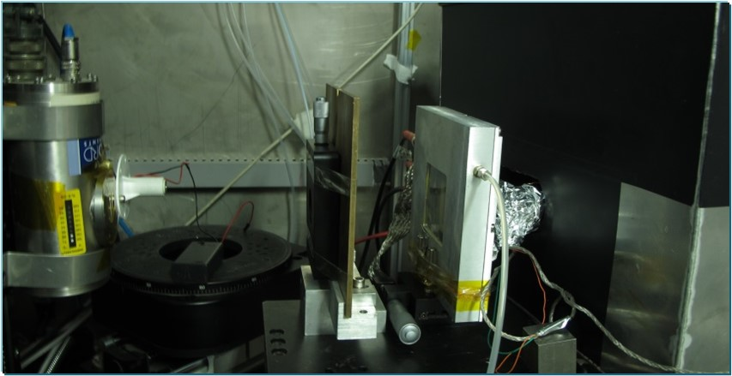

Figure 3 Test Platform Setup



Figure 4 Test Platform Structure

In order to verify this method, an X-ray imaging verification test was carried out on a 5×5 cm2(100×100, 0.5mm each strip) Thick Gas Electron Multiplier (THGEM) detector, using an 8 keV Cu X-ray source with 100μm slit borad, where 200 strips were read out by 30 encoded readout channels. A manual movable platform was used for the position scanning test. The test platform setup is shown in figure3 and the test platform structure is shown in figure4. X-ray beam pass through Cu board engraved with letters to detector. Then electronics based on the VATA160 chip read out the signals. Finally by decoding the channels’ signals we get the hit position and rebuild the pictures with letters, thus two-dimensional imaging is implemented.

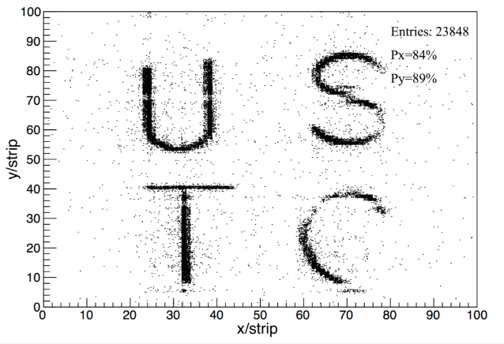

Figure 5 Imaging result

Figure5 is the rebuilt image when considering the noise of electronics is about 10fC, 3 times of the baseline noise. For X direction, about 16% of events hit only have 1strip cluster size and can’t be decoded. For Y direction the rate is about 11%. The test results indicate this method is feasible for two-dimensional readout of THGEM.

Figure6 and figure7 are the cluster size distribution on X and Y direction. Position RMS on X direction is 0.95 strip(0.475mm), and on Y direction is 0.85 strip(0.425mm). The result shows that encoded multiplexing readout method is feasible for two-dimensional tracking. Lower-noise electronics are indispensable if we want clearer image.

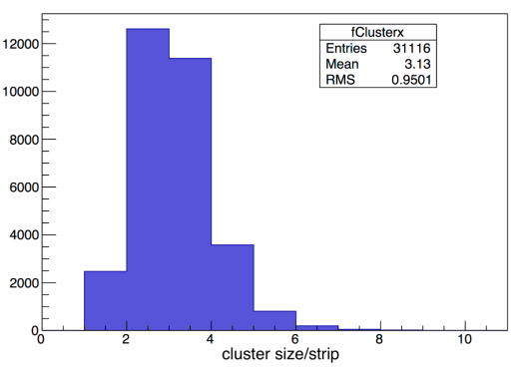

Figure 6Cluster size distribution on X direction

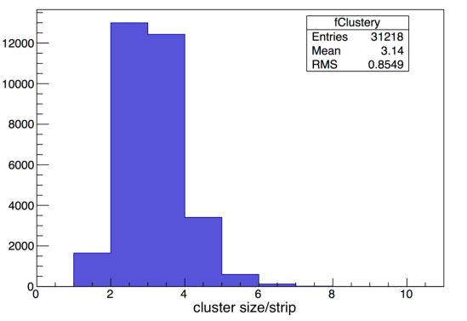

Figure 7Cluster size distribution on Y direction

# **Conclusion**

The test results show the method has a good performance in two-dimensional imaging for GEM, and has an attractive potential to help build MPGDs with large number of readout strips. As this two-dimensional readout method can dramatically reduce the number of readout channels, it can also has a wide range of position imaging applications besides particle physics, such as medical imaging and industry.

# **Reference:**

[1] Abbon P, Albrecht E, Alexakhin V Y, et al. The COMPASS experiment at CERN[J]. Nuclear Instruments and Methods in Physics Research Section A, 2007, 577(3): 455-518.

[2] Iakovidis G. The Micromegas project for the ATLAS upgrade[J]. Journal of Instrumentation, 2013, 8(12): C12007.

[3] Qi B X, Liu S B, Ji H, et al. A Novel Method of Encoded Multiplexing Readout for Micro-pattern Gas Detectors[J]. arXiv preprint arXiv:1509.02229, 2015.